

**Comprehensive Relative Strength Analysis & Market Intelligence**

I've processed your RS data and created multiple visualizations and analytical frameworks to understand current market dynamics, leadership patterns, and trading opportunities.

**Key Visualizations**

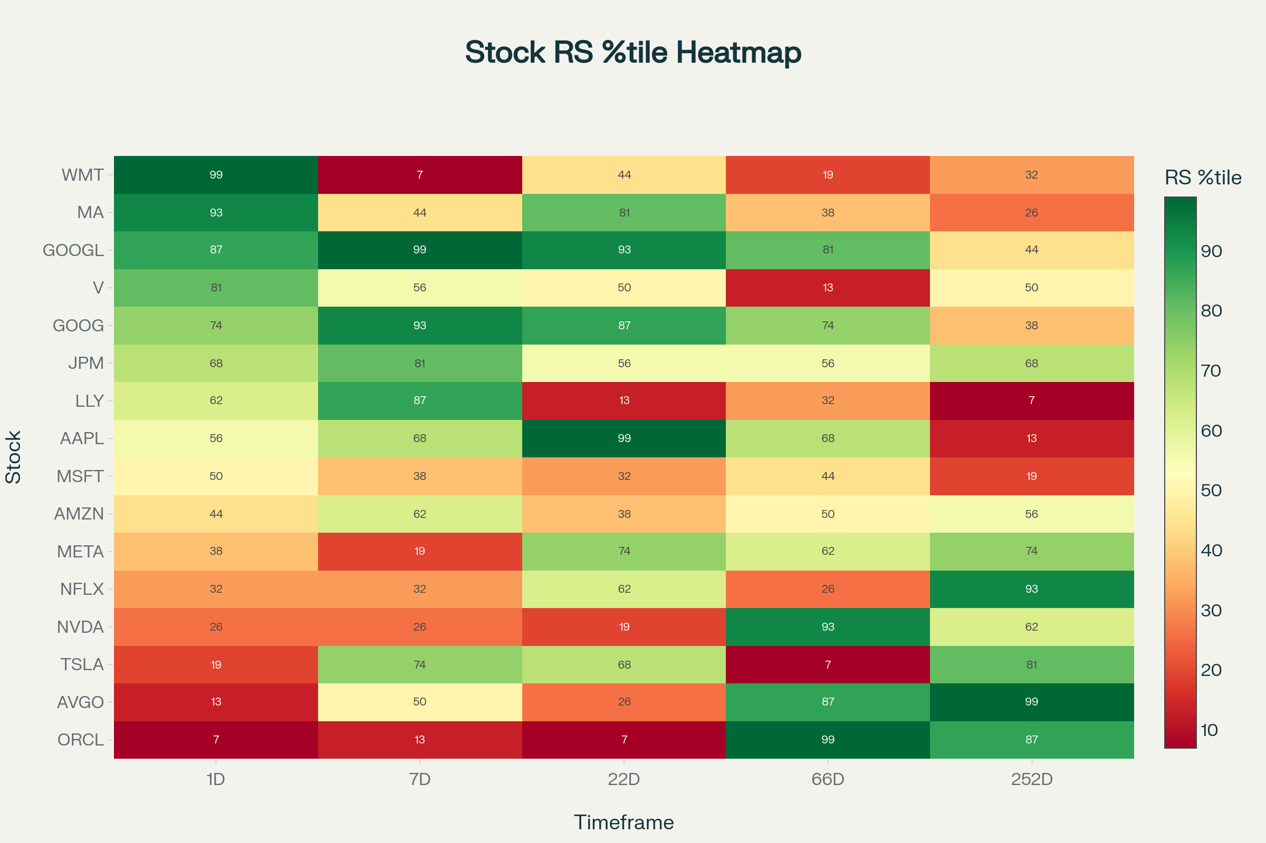

Stock RS Percentile Heatmap - Multi-Timeframe Analysis

This **Multi-Timeframe RS Heatmap** reveals fascinating momentum patterns. **GOOGL and GOOG show consistent strength** across most timeframes, while **WMT demonstrates extreme short-term leadership** (99th percentile) but weakness in longer timeframes, suggesting a potential momentum fade.

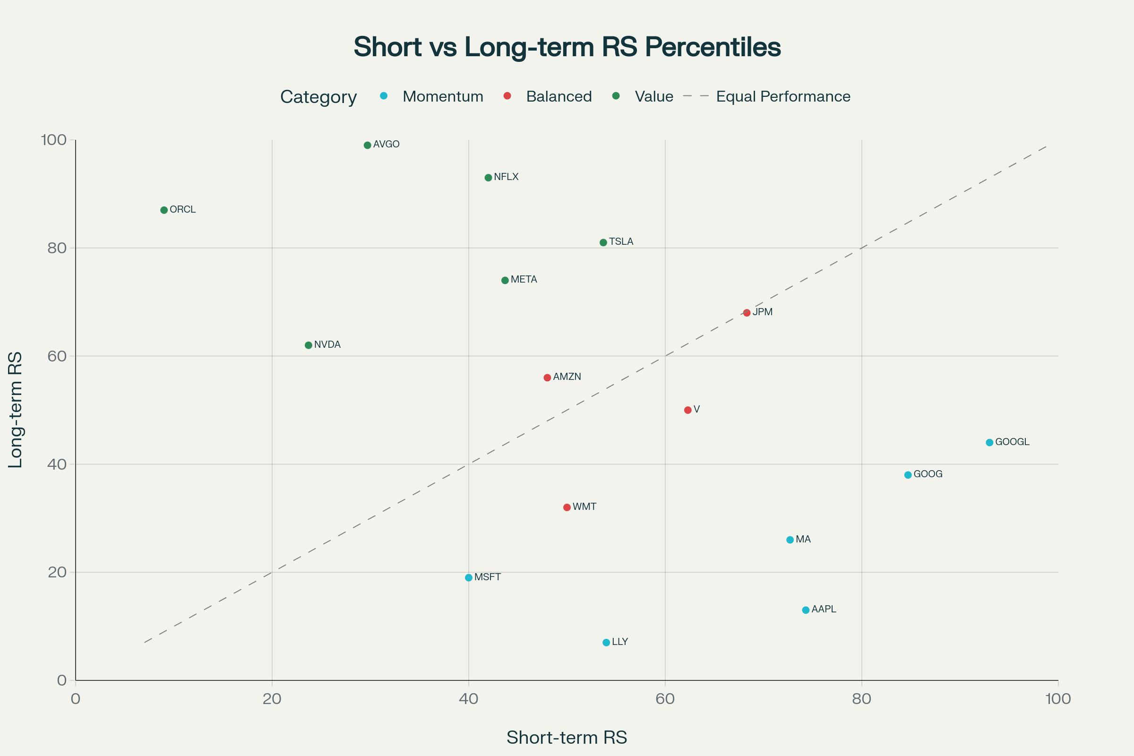

Momentum vs Value Analysis - Short-term vs Long-term RS

The **Momentum vs Value scatter plot** clearly categorizes stocks into actionable trading groups. **Momentum leaders** (below the line) like GOOGL, AAPL, and LLY show strong short-term performance exceeding long-term trends, while **value turnarounds** (above the line) like ORCL, AVGO, and NFLX display strong long-term RS with recent short-term weakness.

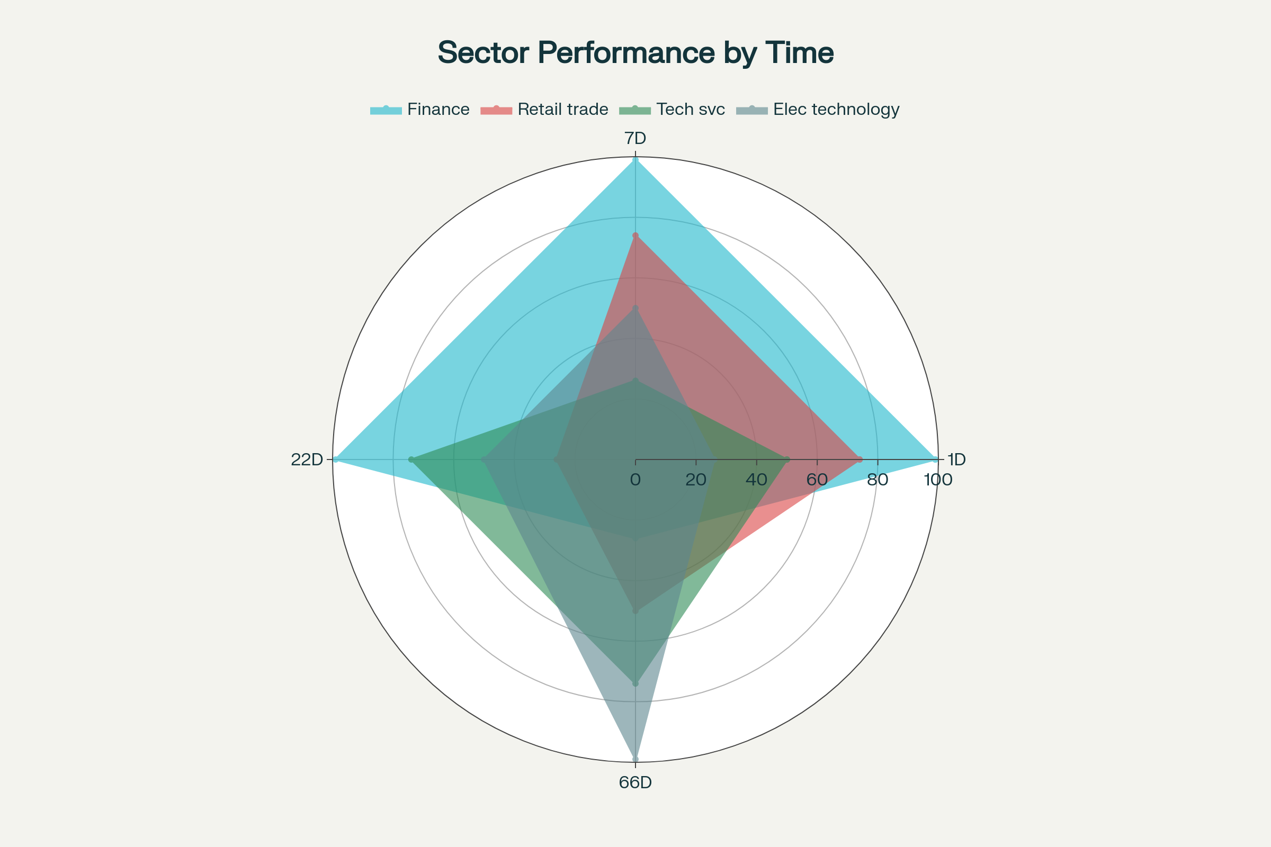

Sector RS Performance Radar - Multi-Timeframe Comparison

The **Sector Radar Chart** highlights a critical **sector rotation pattern** - **Finance dominates short-term timeframes** (99th percentile across 1D, 7D, 22D) while **Electronic Technology shows exceptional long-term strength** (99th percentile at 66D) despite current weakness.

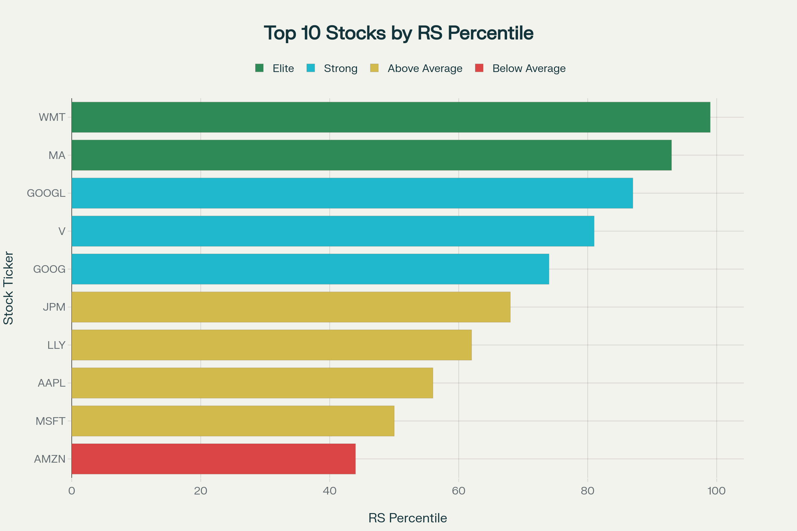

Top 10 Stock Leaders by Current RS Percentile

This **RS Leadership ranking** shows current market structure with **only 2 elite performers** (90%+ RS), indicating **narrow leadership** - a higher risk environment requiring careful stock selection.

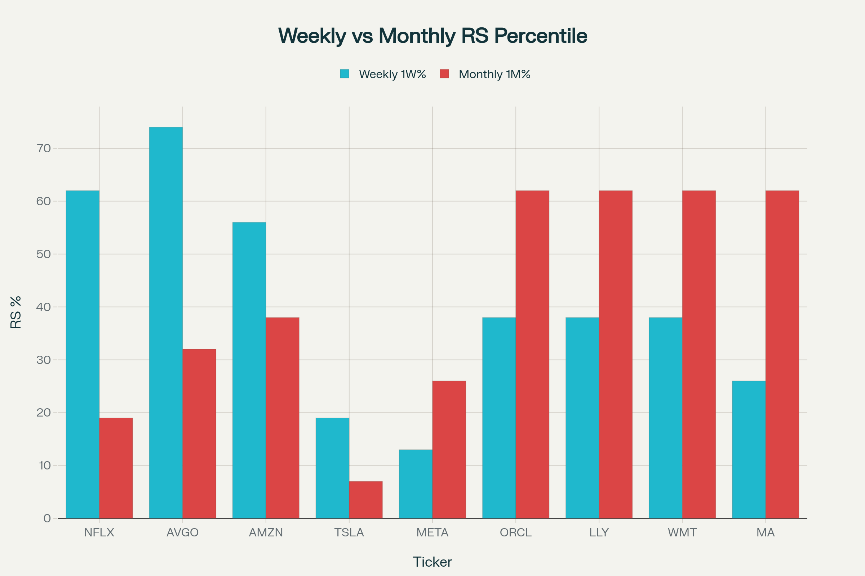

Weekly vs Monthly Momentum Analysis

The **Weekly vs Monthly Momentum Analysis** identifies **recent acceleration** in NFLX (+43%), AVGO (+42%), and **deceleration** in traditionally strong names like MA (-36%), signaling potential trend shifts.

**Critical Market Insights Discovered**

**🏆 Current Leadership Structure**

* **Elite Leaders**: WMT (99%), MA (93%) - but watch for momentum fading
* **Consistent Quality**: GOOGL, GOOG, JPM - stable across timeframes
* **Market Structure**: Narrow leadership (12.5% elite) indicates higher risk

**🔄 Sector Rotation Signals**

* **Finance**: +73% momentum advantage - strong institutional inflows likely
* **Electronic Technology**: Building long-term base (99% 66D RS) despite short-term weakness
* **Internet Software**: Consistent leadership across all timeframes

**💡 Actionable Trading Strategies**

1. **Momentum Breakout Plays**: GOOGL, GOOG, AAPL - ride short-term strength
2. **Value Turnaround Candidates**: AVGO, NFLX, ORCL - wait for RS confirmation
3. **Recent Accelerators**: NFLX, AVGO, AMZN - potential trend continuation
4. **Quality Core Holdings**: GOOGL, GOOG, JPM - consistent performers

**⚠️ Risk Assessment**

* **High Volatility Names**: AAPL, LLY, MA, WMT - require tight risk management
* **Narrow Leadership**: Only 12.5% elite performers suggests fragile market structure

**Key Analytical Discoveries**

**Momentum Patterns**: Clear divergence between short-term momentum leaders (GOOGL +49% vs long-term) and value turnarounds (ORCL +78% long-term vs short-term)

**Sector Dynamics**: Finance sector rotation happening NOW (+73% momentum), while Tech sector bifurcated (Software leading, Semiconductors lagging short-term)

**Recent Changes**: Weekly momentum acceleration in NFLX/AVGO suggests new money flows, while deceleration in MA/WMT indicates potential rotation

The comprehensive analysis provides a complete framework for understanding current market leadership, identifying emerging trends, and positioning for both momentum continuation and mean reversion opportunities across multiple timeframes.

⁂

1. rs_ibd_industries_0_daily_20250906.csv

1. <https://ppl-ai-code-interpreter-files.s3.amazonaws.com/web/direct-files/4c8eaaac345c27465840b8d79381a9a0/7f47c981-c32a-4558-87a5-c7718c3d8f3d/68f84dbc.csv>

1. rs_ibd_industries_0_monthly_20250906.csv

1. rs_ibd_industries_0_weekly_20250906.csv

1. rs_ibd_sectors_0_daily_20250906.csv

1. rs_ibd_sectors_0_monthly_20250906.csv

1. rs_ibd_sectors_0_weekly_20250906.csv

1. rs_ibd_stocks_0_daily_20250829.csv

1. rs_ibd_stocks_0_monthly_20250829.csv

1. rs_ibd_stocks_0_weekly_20250825.csv